This is a work in progress!

Workshop: Python for Geospatial Big Data and Data Science Using the FASRC

Exercise 1

# Login to the FASRC web interface

* https://rcood.rc.fas.harvard.edu/
* Start an interactive Jupyter notebook session
  + Default settings are ok
  + In Jupyter, create a new Python Notebook, name it test.ipynb
  + Run a simple demo code (e.g. print("Hello World"))

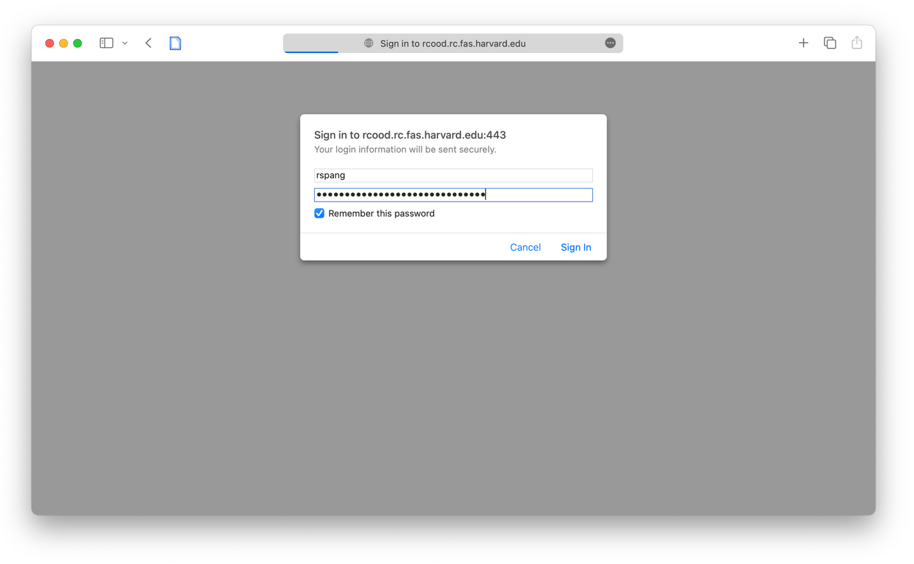

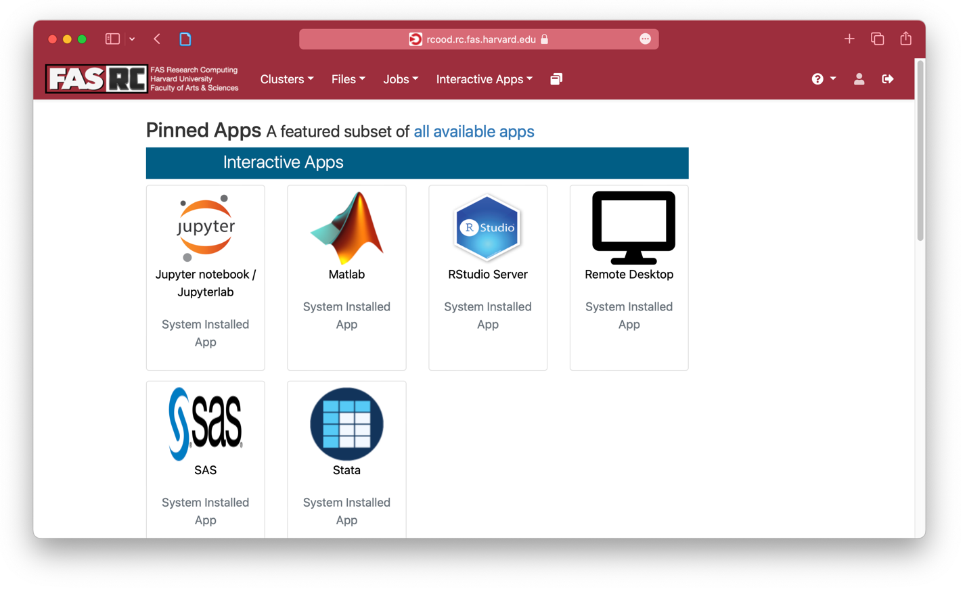

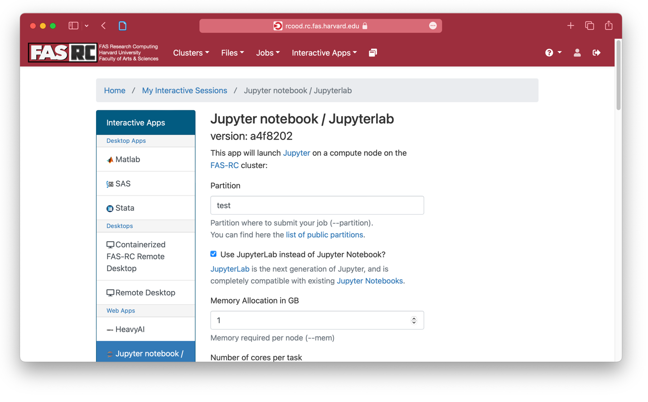

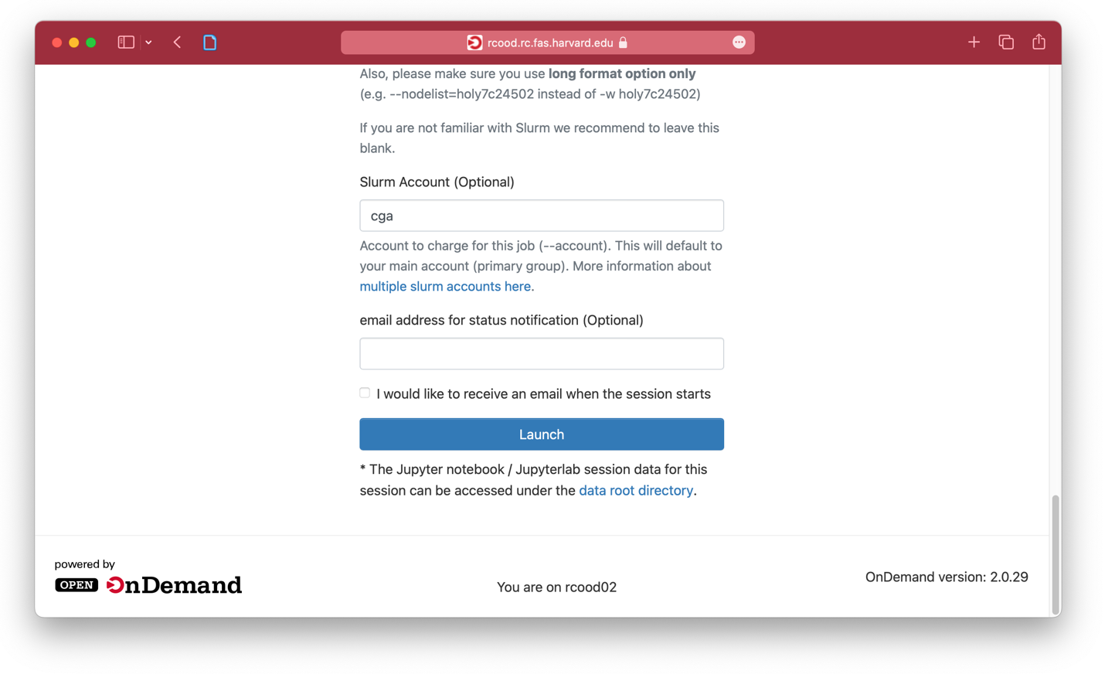

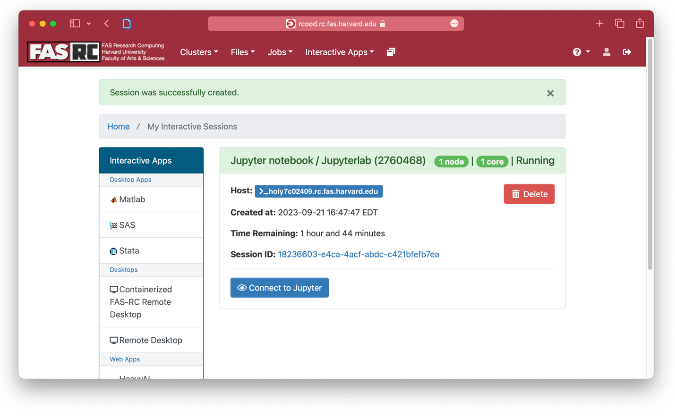

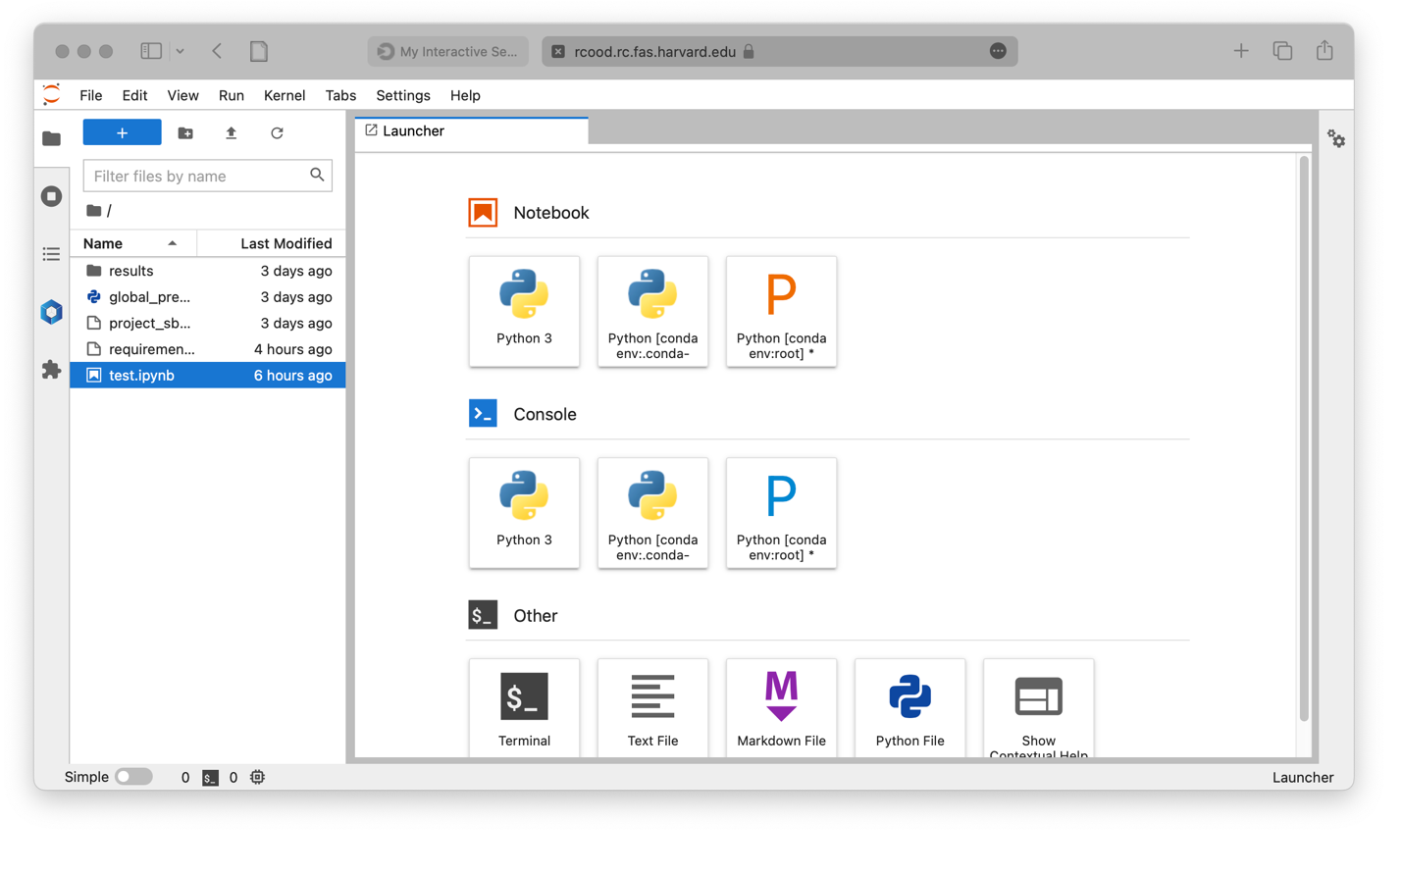

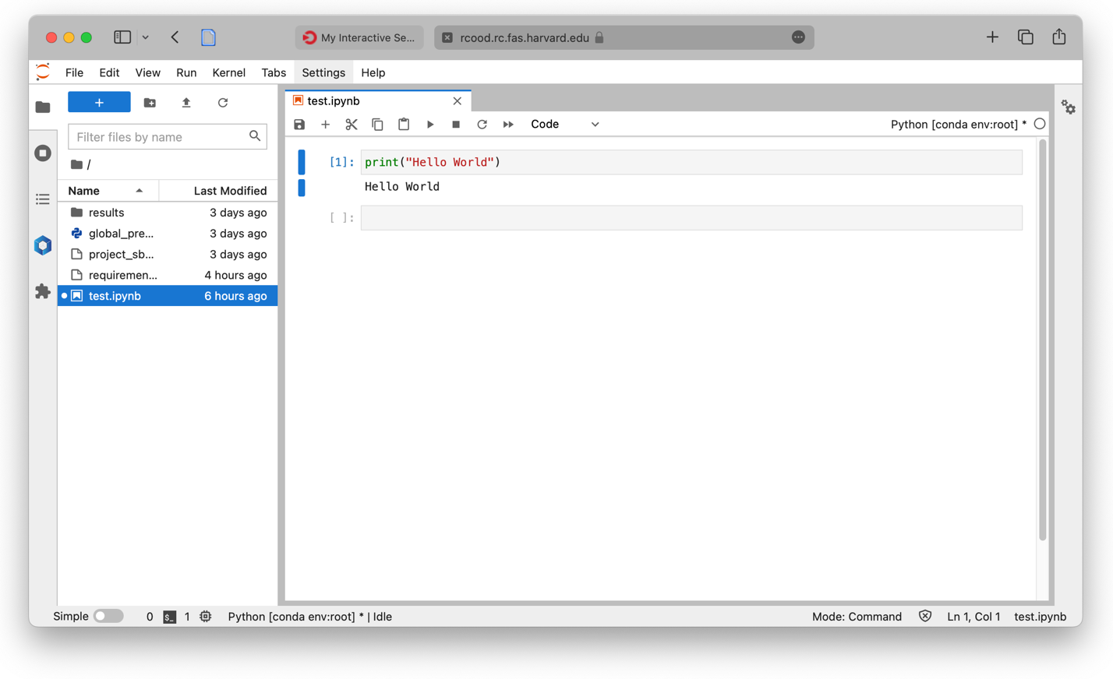

* Login to the cluster via SSH
  + ssh user@login.rc.fas.harvard.edu
* Setup a python environment
  + Load the Python / mamba module
    - module load Mambaforge/23.3.1-fasrc01
  + Create a new *mamba* environment
    - mamba create -n workshop python=3.9 --file requirements.txt
* Start an interactive shell on a compute node
  + srun --pty -p test --mem 1000 -t 0-01:00 /bin/bash
* Load Python module & start environment
  + module load Mambaforge/23.3.1-fasrc01
  + mamba activate workshop
* Run Python code
  + jupytext --to py test.ipynb # convert .ipynb to .py
  + python test.py